Question 2: Enzyme Kinetics

1.

By using the law of mass action, we can get four equations for the rate of changes of the four species:

$$\begin{aligned}-\frac{dc_{E}}{dt}=k_{1}c_{E}c_{S}-k_{2}c_{ES}-k_{3}c_{ES}\#\left(1\right)\end{aligned}$$

$$\begin{aligned}-\frac{dc_{S}}{dt}=k_{1}c_{E}c_{S}-k_{2}c_{ES}\#\left(2\right)\end{aligned}$$

$$\begin{aligned}\frac{dc_{ES}}{dt}=k_{1}c_{E}c_{S}-k_{2}c_{ES}-k_{3}c_{ES}\#\left(3\right)\end{aligned}$$

$$\begin{aligned}\frac{dc_{P}}{dt}=k_{3}c_{ES}\#\left(4\right)\end{aligned}$$

where $c_{E},c_{S},c_{ES},c_{P}$ represents the concentration of E, S, ES and P respectively.

2.

Under given initial conditions, we can use fourth-order Runge-Kutta method to solve the above ordinary differential equation system. The numerical solution results of the ordinary differential equation system are as follows:

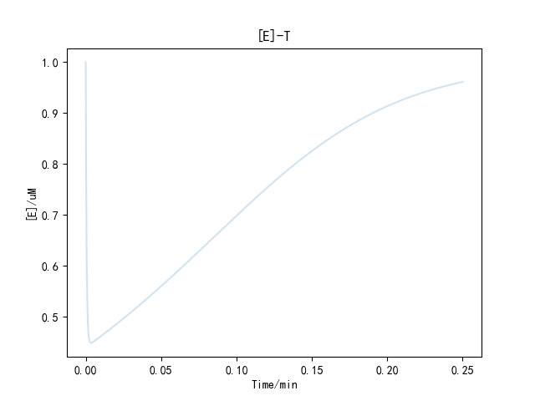

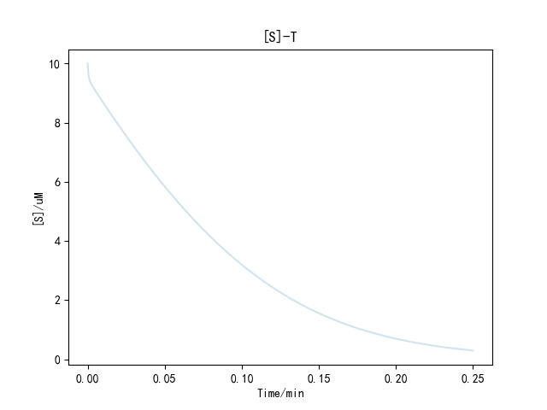

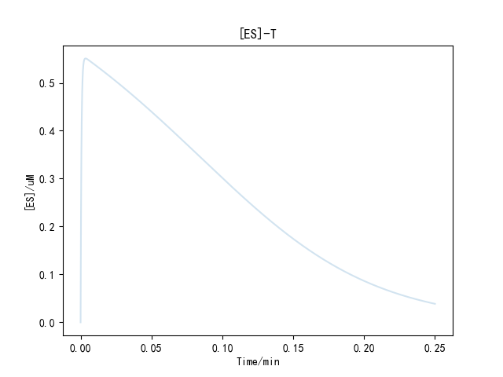

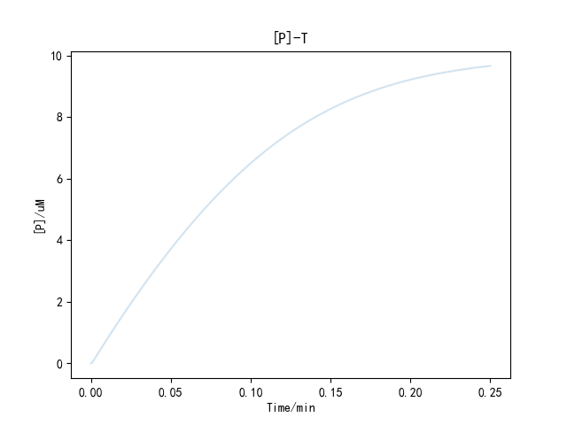

3.

Plot the velocity V as a function of the concentration of the substrate S:

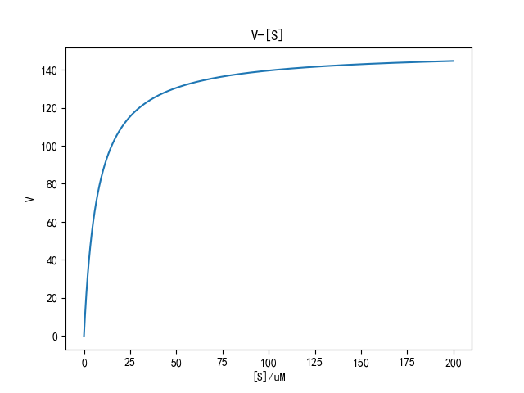

From the figure, we can find that when the concentrations of S are very small, the velocity V increases approximately linearly. However, when the concentrations of S are large, the velocity V saturates to the maximum value $V_{m}=150μM/min$.

We can also solve $V_{m}$ by theoretical derivation.

$$\begin{aligned}V=\frac{dc_{P}}{dt}=k_{3}c_{ES}\#\left(5\right)\end{aligned}$$

According to the steady state approximation:

$$\begin{aligned}\frac{dc_{ES}}{dt}=k_{1}c_{E}c_{S}-k_{2}c_{ES}-k_{3}c_{ES}=0\#\left(6\right)\end{aligned}$$

$$\begin{aligned}c_{ES}=\frac{k_{1}c_{E}c_{S}}{k_{2}+k_{3}}\#\left(7\right)\end{aligned}$$

Assume that the initial concentration of E is $c_{E_{0}}$:

$$\begin{aligned}c_{E}=c_{E_{0}}-c_{ES}\#\left(8\right)\end{aligned}$$

$$\begin{aligned}V=\frac{k_{3}c_{E_{0}}c_{S}}{\frac{k_{2}+k_{3}}{k_{1}}+c_{S}}\#\left(9\right)\end{aligned}$$

$$\begin{aligned}V=\frac{150×1×c_{S}}{\frac{600+150}{100}+c_{S}}=\frac{150c_{S}}{7.5+c_{S}}\#\left(10\right)\end{aligned}$$

$$\begin{aligned}\lim_{c_{S}→∞}V=\lim_{\left[S\right]→∞}{\frac{150c_{S}}{7.5+c_{S}}=\lim_{c_{S}→∞}\frac{150}{\frac{7.5}{c_{S}}+1}=150}μM/min\#\left(11\right)\end{aligned}$$

So, we can draw the same conclusion when the concentrations of S are large, the velocity V saturates to the maximum value $V_{m}=150μM/min$.